PUBLIC RELATION CASE STUDIES
1 .John’s baby powder:

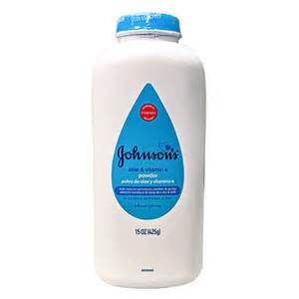
On Friday, December 14, 2018, Reuters published a story about Johnson & Johnson (J&J) baby powder that misrepresented J&J, our product, our actions, and the science about talc. Reuters misled its readers by printing inaccurate statements, withholding crucial information that otherwise undermines its thesis. Reuters published this story even though it was advised that it had the facts wrong.
Prior to publication, Reuters was supplied with substantial amounts of information that demonstrated the following that was ultimately omitted from the final article:
- J&J’s baby powder is safe and does not cause cancer. Studies of tens of thousands of women and thousands of men show that talc does not cause cancer or asbestos-related disease.
- For decades, J&J’s baby powder has repeatedly been tested for asbestos and been found not to contain asbestos.
- J&J has cooperated fully and openly with the U.S. Food & Drug Administration and other global regulators, providing them with all the information they requested over decades. We have also made our cosmetic talc sources and processed talc available to regulators for testing. Regulators have tested both and found no asbestos. To say we hid anything is false.
The information Reuters relied upon has been publicly available for years...

Reuters’s story ignored the overwhelming science showing that talc does not cause cancer.Reuters declined to report on the critical, dispositive science conducted by independent, leading health researchers that examined the carcinogenic effects of cosmetic talc products and concluded that talc is safe and does not cause ovarian cancer or mesothelioma.
- Ovarian Cancer Studies. Reuters did not mention the scientific studies of tens of thousands of women who use talcum powder, which show no increased risk of ovarian cancer.
- These studies were conducted by scientists at institutions including Harvard Medical School, Harvard School of Public Health, the University of Massachusetts Amherst, and the National Institute of Environmental Health Sciences.
- Talc Miners and Millers Studies. Reuters deemphasizes the multiple peer-reviewed studies of thousands of miners and millers from the areas where J&J historically sourced its talc. These are the best people to study since they were working the closest with the talc every day, and no cases of mesothelioma were found. Reuters mentions the study of Vermont miners and millers without mentioning that the study found no cases of mesothelioma.
- Other Studies. Reuters also omits that other studies of cosmetic or pharmaceutical talc have established that talc does not cause mesothelioma. Large-scale reports on patients who had a medical procedure done in which talc was actually injected into the linings of the lungs found that none developed mesothelioma. Animal studies in which rodents were injected with talc sourced from the deposits J&J used did not result in mesothelioma.
- There is not a single, sound study showing that talc causes mesothelioma. Again, Reuters was informed of this and omitted these facts.
II. Reuters misinformed its readers about the facts showing J&J talc does not contain asbestos.
A. Although Reuters received dispositive information showing that today’s talc – mined in China for the last 15 years – does not contain asbestos. Reuters chose not to inform its readers of this fact.
- Reuters was requested to clearly report this fact so consumers would know there has been no asbestos in talc on the market over the last 15 years, and Reuters chose not to do so in its article. In fact, routine J&J testing records go back at least to the 1970s and show no asbestos in talc used in baby powder.
- After the article came out, the Reuters reporter appeared on CNBC’s “Power Lunch,” MSNBC’s “Velshi & Ruhle,” and NBC’s “Nightly News” programs on Friday, December 14, 2018, and made this very point. In the “Power Lunch” interview, she said, “There’s no evidence that what [J&J is] selling today [] has any asbestos in it” but claimed she hadn’t looked at the evidence. On the “Nightly News,” however, it was disclosed that the Reuters reporter acknowledged that J&J had provided test reports for the last 15 years that showed no asbestos was found in J&J talc.
- Reuters knows that plaintiffs’ lawyers in the recent Henry trial, where the jury ruled in favor of J&J, agreed that “[t]he China mines don't have asbestos in them.” Yet, Reuters did not include this in its article.
- For decades, independent tests of thousands of samples of our talc mines and processed talc by the world’s leading labs, regulators, and most prominent universities have found that our talc does not contain asbestos. Nevertheless, Reuters failed to disclose to its readers the independent institutions, laboratories, and universities that tested J&J’s cosmetic talc and concluded it did not contain asbestos.
2. Todd Defren runs SHIFT Communications
Todd Defren runs SHIFT Communications, a public relations firm that specializes in digital and social media that has served clients including McDonald’s, Salesforce.com, TechCrunch, H&R Block and Tyson Foods. Defren is also a highly influential blogger with a large number of readers of his PR Squared blog.28 Defren has highlighted some new dilemmas unique to social media.
Let’s use Fitzpatrick’s process to walk us through one of Defren’s cases, “Tweeting Under False Circumstances.”29 (Quoted material from Defren’s blog post.)

Define the specific ethical issue/conflict
A client asked Defren and his associates to tweet for him at a trade show from the client’s Twitter account. The client was adept at Twitter and prominent in his field. The client had a significant number of loyal followers on his account who were used to hearing directly from him via that channel.
- He posts regularly, sometimes several times a day. He “gets” Twitter; he finds value in the dialogue and his followers appreciate that a well-placed exec from a Big Company is engaged with them online. Now, a big industry tradeshow is coming up. He’ll be very active there, as a speaker and organizer. The executive wants his tweetstream to reflect his activity at the show, and to highlight other happenings at the conference, as well. He’s very concerned that he won’t be able to support this many to-do’s.

Identify internal/external factors
A big part of the appeal of Twitter as a form of social media is that followers have access to interesting and influential people with whom they otherwise would not be able to interact. The culture of social media is an external factor that must be considered, and the executive’s commitment to authenticity in this environment is an internal factor.
- You can see how this request comes from a “good place.” This executive’s commitment to online engagement is so fierce, he doesn’t want to abandon it even for an important event. He knows his followers would understand his absences, but he thinks there is going to be real value in tracking what’s happening at the conference, and in responding to folks online throughout.

Identify key values
Loyalty, transparency, expertise and independence are among the key values in this case. Not only does Defren have to weigh his loyalty to the client, but he also must consider the loyalty and trust that the client’s Twitter followers may have in the executive. This loyalty brings transparency to the forefront because if those followers expect the executive to write all his own tweets and if he is planning on changing that without telling them, they may be deceived. The behind-the-scenes change would mean a lack of transparency. The client means no harm—his request comes from a good place as Defren said—but part of what he is paying Defren and his firm for is expertise in knowing the lay of the land in social media and counseling on exactly this type of situation.
- While it’s true he is asking us to misrepresent ourselves, he feels that it would still be authentic because of his trust in us.

Identify the parties who will be affected
This is where those competing duties to various people come into play. This case appears to be a doozy because Defren has a duty to pretty much everyone on Seib and Fitzpatrick’s list: (1) himself, (2) his client, (3) the profession, (5) the media and (6) society.
- Duty to self: As is pretty clear from his blog, which includes detailed analysis of ethical dilemmas like this one, Defren invests his own intellect, hard work and time in his strategic communication practice. If he botches this, it could damage his reputation and lead to personal disappointment. There also could be financial consequences for him personally.
- Duty to client: Defren’s firm has been hired to do a job. Yes, a big part of that job is to communicate for the client, but he also owes the client solid independent counseling based on his expertise and knowledge of social media.
- Duty to the profession: Not only will botching this job with poor ethical decisionmaking discredit Defren; it also may reflect poorly on the whole field of public relations. Unfortunately, examples of misrepresentation and deception in public relations are not hard to find as these cases tend to get called out and told and retold online. Mentioning public relations and ethics together in the same sentence will lead to rolled eyes and snarky responses in many circles. The only way to combat this is with performance.
- Duty to the media: The media in this case are mostly social media, Twitter users in particular. Just as relationships with reporters, editors and producers are critical to effective communication via magazines, newspapers, radio and television, relationships with Twitter users are the essence of effective tweeting. If Defren disappoints his client’s followers, he’s not only undermined his client’s credibility and effectiveness but will also have taken something away from the utility of the medium as a whole.
- Duty to society: Social media have the potential to facilitate meaningful democratic dialogue and healthy economies by affording publics the opportunity to engage organizations in the honest exchange of ideas, currency, products, services and social capital. Social media also can provide a haven for misinformation, deceit, mistrust, cynicism and generally shattered expectations. I’m guessing Defren wants to contribute to the former and not the latter.

Select ethical principles to guide the decision-making process
At this stage of the analysis it becomes fairly clear that openness, honesty, trust, transparency and authenticity are at stake. Deontological ethics are systems of decision-making that focus on duties or rules. To the degree that the principle of duty is central to the decision on how to act in this case based on moral obligations to each of the parties, you could say that it guides our thinking. Of course, other principles apply too, and we will look at some of those in cases in the chapters that follow.

Make a decision and justify it
So what did Defren do?
- So we suggested a compromise. . . . Yes, we would tweet from his account, but with the following conditions:
- Prior to the event, he must tweet, “During the show some of my tweeting will be supplemented by our extended team.”
- A reminder to that effect would go out, regularly, throughout the conference, i.e., every 10th tweet would remind followers that someone besides the executive might be “at the controls” of his Twitter account.
- When character spaces permitted, we’d add a #team hashtag to denote that the tweet was not published by the exec—but honestly, this attribution fell away more often than not; we largely relied on the “every 10th tweet” approach to cover our ethical backsides.
In the end, the solution seemed easy, but this was largely due to Defren’s expertise and careful ethical thinking. He was able to serve the client well with a compromise that didn’t require compromising his ethics or causing harm to his business, his profession or society. Defren and his client experienced no “pushback” from the tweets. Interestingly, he still had some ethical concerns and questions (about whether some people would still be duped despite the every-tenth-tweet approach) and was courageous enough to post the whole case as well as his followup concerns in a very public blog entry inviting feedback. When I checked last, there were more than 150 comments on the post, and the vast majority of them were constructive and supportive. The very act of airing his case and concerns for open discussion honors the spirit of social media while also reinforcing Defren’s commitment to ethical practice—in the sense of the word “practice” that means that we are all always working to improve in this area.

Red Bull’s Content Marketing Strategy
By most definitions, content marketing is still pretty much straight marketing in its goals. The “targets” are still labeled customers, buyers, and audiences, but the fact that it involves organizational storytelling and communication engagement that likely resonates well beyond sales makes it an important point of integration in an organization’s communication efforts. Red Bull is a prime example. As Mashable tech writer James O’Brien put it, “Red Bull is a publishing empire that also happens to sell a beverage.”
I’m trying to write a book here, and Red Bull is making it really hard for me to stay focused. I just opened www.redbull.com to do some research, and I found myself seven minutes into a video of snowboarder Pat Moore, watching him pull a front-side 360 off a three-story parking garage before being chased away by the building’s security crew. I even had to skip an “ad” for Microsoft OneDrive to get to the video “content” on Red Bull’s embedded YouTube channel. I can’t tell the video series from the advertising from the marketing from the public relations.
They’ve got fantastic photography, incredible videos, sharply written feature stories, and inspiring blogs by extreme athletes. Not only do they have the obligatory Facebook, Twitter, Google+, Instagram, YouTube, and Pinterest buttons, but the content is actually something I might want to share with my friends on these networks (or in my book-writing as with the picture of surfer Carissa Moore).
From a strategy standpoint though, the most interesting part is that there is no mention whatsoever of the Red Bull beverage product unless I seek it out. In the far upper-right corner of the Web page there are two small links for “products and company” and “shop.” That’s content marketing.

4 The Issue Lifecycle of Volkswagen’s Dieselgate
Volkswagen’s diesel emissions scandal, dubbed “dieselgate” by some and “the diesel dupe” by others, provides an example of how an issue can grow into a full-blown crisis with major consequences.

Early/potential
At the earliest stages, issues are often identified first by experts or specialists who pay close attention to small changes in the internal or external environments of organizations. When these experts or specialists perceive a potential problem and people within an organization begin planning to respond in some way, the issue has entered the early/potential stage.
In 2012, Arvind Thiruvengadam, an assistant professor at West Virginia University, and a few of his colleagues won a grant from the International Council on Clean Transportation (ICCT) to test the environmental friendliness and fuel efficiency of diesel cars. As part of their research, Thiruvengadam and his team ran emissions tests on a 2012 Volkswagen Jetta and a 2013 VW Passat. In the decade prior, Volkswagen’s marketing message had emphasized ‘clean diesel.’ Therefore, Thiruvengadam and his team expected to find that these two VW models, which were designed for sale in the United States would run cleaner than cars sold in other countries with more lax emission standards. Instead, the researchers were surprised to find that the two VWs emitted significantly higher levels of pollutants.
In May 2014, the ICCT alerted the Environmental Protection Agency (EPA) and the California Air Resources board about the unexpected findings. At this point, Volkswagen had a potential issue. In fact, it was later revealed that people inside the company had known about the emission problem since 2005, so the early/potential stage for this issue lasted nearly ten years.

Emerging
In the emerging stage, groups begin to form and take sides on an issue. In their book, Risk Issues and Crisis Management in Public Relations, Michael Regester and Judy Larkin describe the emerging phase as a time when industry insiders, specialist media, professional interest groups, activist organizations, or any other publics with direct interest, begin to notice and to voice concerns or opinions. Media attention may be sporadic in this stage, but if public relations people are monitoring the media, including specialty media like blogs and trade publications, they still may have an opportunity to intervene and begin to formulate plans for action. As mentioned previously, the more an issue develops, the fewer options there are available for proactive management both internally and externally.
There was very little media attention for several months after the fuel efficiency researchers published their results. Volkswagen denied there was a problem and offered other explanations for why results from the road tests did not meet the expected standards. Meanwhile, regulators continued to investigate. The issue was emerging.

Current/Crisis
In the current/crisis stage, the issue matures, and pressure builds as the impact of the issue on the organization becomes clear. Public relations people have very little control of the situation at this stage. Strategy options become mainly reactive. According to Regester and Larkin, issues become enduring and pervasive in the current stage. They increase in intensity. In September of 2015, the EPA publicly accused VW of using “defeat devices” hidden in its diesel cars that manipulated the results of emissions tests. Basically, the devices were software designed to detect when cars were undergoing an emissions test and then improve performance accordingly. Volkswagen had been caught cheating.
On September 21, 2015, Volkswagen Group of America’s chief executive Michael Horn had to use what should have been an occasion to celebrate—the company’s launch event for its 2016 Passat—to issue an apology instead. “Our company was dishonest, with the EPA and the California Air Resources board, and with all of you, and in my German words, we have totally screwed up,” Horn told the Brooklyn, NY audience. “We have to make things right, with the government, the public, our customers, our employees and also very important, our dealers.” Volkswagen was amidst a crisis that had spun well beyond its control.
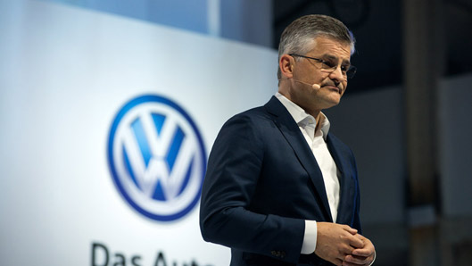
“We have totally screwed up,” announced Volkswagen Group of America’s chief executive Michael Horn in September 2015. Imagine you are an owner of one of the cars (or maybe you are an owner) affected in ‘diesel dupe,’ what could Volkswagen do “to make things right”?
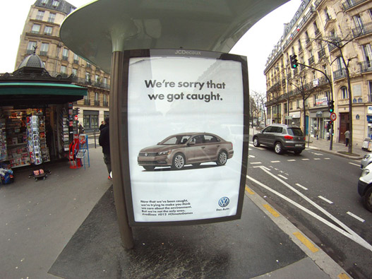
Following its diesel crisis, Volkswagen became the target of the brandalism movement (e.g., www.brandalism.org.uk) as part of a protest campaign tied to international climate change talks. How could Volkswagen have responded (if at all)?
Consider for a moment how you would feel if you owned one of the approximately 10,000 affected cars in the United States sold by Volkswagen (e.g. VWs, Audis, or Porsches). You’ve chosen to invest in what you believe to be smart, environmentally friendly technology, only to learn that your now-highly-devalued car emits “up to nine times the legal limit of smog-produced nitrogen oxide pollutants.” Is it safe to say you’d be, um, peeved?
Now think of how dealers and employees felt, not to mention the governments and regulators who were deliberately deceived. When an organization has damaged relationships like this with so many key publics, it is clearly in crisis mode. In Volkswagen’s case, all they could do at this point was react to a series of painful consequences as they unfolded:
- The company admitted that 11 million of its diesel cars had been “rigged to fool emissions tests,” going back to 2005 when it began focusing major marketing efforts on selling diesel cars in the United States.
- Volkswagen chief executive Martin Winterkorn resigned on September 23, 2015.
- By September 25, 2015, Volkswagen stock had plummeted more than 50% below its 52-week high in March 2015.
- The value of used VW and Audi diesels fell more than 13% in the month following the EPA announcement.
- By late October 2015, more than 350 U.S. lawsuits against Volkswagen had been filed, and legal experts expected many of those suits to be consolidated into mass class action suits. Volkswagen reportedly had set aside $7.3 billion to prepare for the fallout from the crisis, no doubt including the millions of vehicle recalls.
- The company faced the likelihood of regulatory action following investigation from governments across the globe, including Germany, France, Australia, India, China, the European Union, South Korea and Sweden—just about any country where the diesel cars were sold.
At the end of 2015, Hans-Dieter Pötsch, chairman of Volkswagen’s supervisory board, said in a press conference that an organizational climate of poor ethical standards was partly to blame, and “there was a tolerance for breaking the rules.”

Dormant
According to Regester and Larkin, an issue reaches the dormant stage when an organization comes to terms with the consequences of the issue. It does not mean, however, that the issue is over and gone. As of this writing, events continue to unfold for Volkswagen.

5 Cafe Aylanto gets sealed for serving alcohol
BY STAFF REPORT , (LAST UPDATED SEPTEMBER 7, 2019)
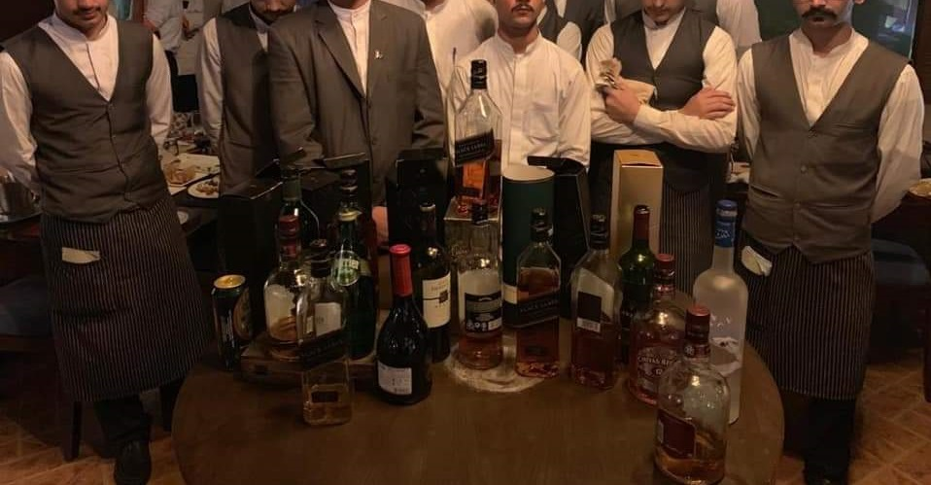
LAHORE: High-end restaurant Cafe Aylanto’s branch at MM Alam Road was sealed on Saturday after several premium bottles of liquor were found on their premises.As per the details, the high-end cafe, which also operates in Karachi and Islamabad, was allegedly allowing customers to consume alcohol along with dinner.Local media reports state that undercover agents were sent to the restaurant. The undercover agents allegedly purchased foreign liquor worth Rs12,000 and signalled two assistant commissioners (AC) who then stepped in and initiated legal action.The undercover operation was carried out at the orders of Lahore commissioner who had tasked AC Revenue Muddassar Nawaz to take action against the cafe if any illegal activity was taking place there.
It is being alleged that the Lahore admin swung into action after the commissioner was refused a table by the restaurant a day ago, upon which he had threatened the eatery with dire consequences.
Later on, Model Town AC Zeeshan Ranjha carried out the raid along with Lahore Excise Department ETO Masood Bashir Waraich and Model Town SP Malik Imran. “Police arrested 13 people and filed a criminal case against the outlet’s administration,” SP Malik Imran said.
Bottles of whiskey, wine, vodka, and beer found in the restaurant were confiscated by the police.
The police also alleged that they had confiscated hashish and meth as well; however, no evidence of the drugs was shown to the media nor was it seen in the pictures and videos recorded by the security officials.
While the police arrested thirteen members of the staff as well as a few customers, the owner of the restaurant, Humaira Sattar, was nowhere to be seen. No official statement has been provided about arresting the owner either.
It may be mentioned here that while many Muslim countries not only serve alcohol openly and leave its consumption to an individual’s personal faith, Pakistan was radicalised under Zia-ul-Haq’s Islamisation plan which banned the use of liquor among other things.
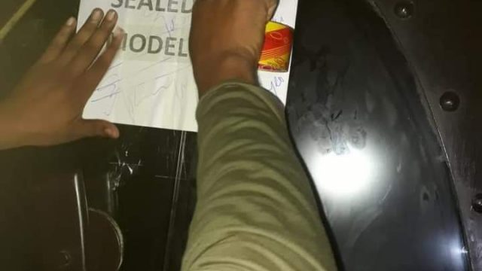
Mahira Khan opens up on pictures of her smoking with Ranbir Kapoor

Last year, pictures of Ranbir Kapoor and Mahira Khan sharing a smoke in New York took the internet by storm.
New Delhi
March 23, 2018
UPDATED: March 24, 2018 11:57 IS

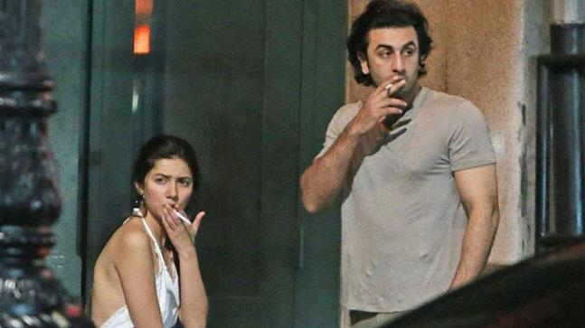
Mahira Khan with Ranbir Kapoor
Last year, pictures of Ranbir Kapoor and Mahira Khan sharing a smoke in New York took the internet by storm. Mahira was relentlessly trolled for several reasons, from smoking to wearing a backless dress, and eventually had to apologise.
On a television show, Mahira talked about the time the pictures were leaked online and said, "That was the first time in my entire career that I was caught up in a so-called controversy and it was strange because there were so many things in that. One, obviously you feel violated, you are in a personal down time moment and someone has just photographed you.
"Two, obviously there was an uproar, because here I was, someone who is extremely loved in Pakistan, and they sort of keep me up on this pedestal you know, they treat me with a lot of love and a lot of respect. And there are certain things I didn't realise that they don't want to see me do."Mahira also said that it was "crazy" and "ridiculous" that her pictures with Ranbir had become a topic of national interest.
Ranbir and Mahira were first clicked together at the Global Teacher Prize event in Dubai. Their pictures sparked speculation that there was a romance brewing between them, and the rumours only intensified when pictures of them chilling in New York hit the internet.
But if reports are to be believed, Ranbir and Mahira's relationship fizzled out after their pictures went viral. The subsequent backlash is said to have taken a toll on their relationship, and they decided to part ways

7 LHC bars action against lawyers in PIC attack case
(LAST UPDATED DECEMBER 18, 2019)
The Lahore High Court (LHC) on Wednesday ordered to stop prosecuting what it dubbed as “innocent lawyers”, vowing to proceed further against “whoever has sinned” during the mob attack at the Pakistan Institute of Cardiology (PIC) in Lahore on December 11.Meanwhile, a bench headed by Justice Syed Mazahar Ali Akbar Naqvi sought personal appearance of the Punjab Chief Secretary Maj (r) Azam Suleman, interior secretary and the Inspector General of Police (IGP) Shoaib Dastgeer in today’s hearing on petitions against ‘reckless’ arrests of lawyers in the wake of the attack on the PIC.The petitions sought the release of lawyers, restraining police from torturing and implicating them in false cases.Pakistan Bar Council (PBC) member Ahsan Bhoon appeared to represent the legal fraternity of lawyers, and argued that the arrested lawyers were subjected to torture by police, and their faces were covered with black veils when they were produced in the court for remand.Bhoon maintained that the lawyers were humiliated and some of the lawyers sitting at Race Course Park, Lahore, were also arrested and tortured.“An apology has been made to the general public [over the incident],” he added.On Dec 16, Judge Arshad Hussain Bhutta of anti-terrorism court (ATC) sent eight more lawyers to judicial remand in the same incident.Speaking to media, Supreme Court Bar Council Vice President Ghulam Murtaza Chaudhry and lawyer Zaheer Anayat Malik said that police presented eight lawyers but failed to provide any investigation report.
The police sought physical remand of the accused lawyers. However, the court rejected the physical remand of lawyers, and instead granted judicial remand.
They further told the media that bail pleas were filed and the court after issuing notices to the parties adjourned the hearing till Tuesday.
‘INQUIRY COMMITTEE’:
On the other hand, an inquiry committee, constituted by Punjab Chief Minister Usman Buzdar to find out the culprits responsible for the violent clash and identify the roles of lawyers, doctors and police, has been carrying out investigation.
The findings by the inquiry committee in a form of a report will be made a part of measures which will be devised and implemented to prevent occurrence of such incidents in the future.Advocate Nadeem Sarwar had earlier filed a petition in the LHC against police raids on lawyers’ homes for their arrest.IG Shoaib Dastgir, Capital City Police Officer (CCPO) Zulfiqar Hameed and PEMRA were made respondents in the application.The application had pleaded with the court to issue directives for the protection of lawyers and halt police from arresting them.Later, Chief Justice of Pakistan Asif Saeed Khosa had termed that the incident “tragic and condemnable”, and stated those who belong to the respected profession would go through the process of self-accountability.CJP Khosa had said that the attack at the PIC should not have occurred at the first place, and expressed sympathy towards the victims and affected families.
“Both, lawyers and doctors, belong to a respected profession and people should be mindful of the values attached to legal as well as medical profession,” he had added. He had expressed hope that “better sense will prevail” not just in this particular incident and its aftermath but in the future as well

8 Pakistan Zainab murder: Imran Ali hanged for six-year-old's death
- 17 October 2018
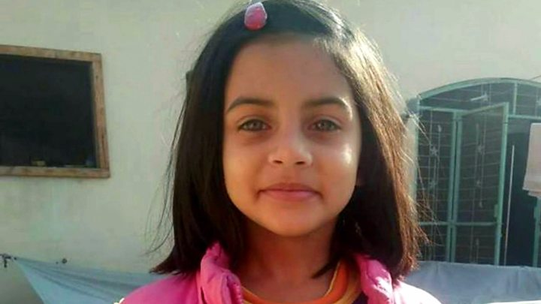
Media captionThe rape and murder of six-year-old Zainab sparked outrage in Pakistan.

Pakistan has hanged a man convicted for the rape and murder of six-year-old Zainab Ansari in January.
Imran Ali, who was arrested after her body was found in a garbage dump, was executed in Lahore's Kot Lakhpat prison early on Wednesday, police said.Zainab's father and other relatives were present.The case, the most heinous in a string of similar child murders in the city of Kasur, had sparked outrage and protests in the country.
After he was sentenced to death for raping and murdering Zainab, Imran Ali was convicted for similar crimes against six more girls.
- Murdered girl's father 'has no words'
- #JusticeForZainab: Anger and anguish
- The city haunted by a spate of child killings
Zainab's father, Amin Ansari, said after the execution that he was "satisfied".
"I have seen his awe-inspiring end with my own eyes," he told reporters.
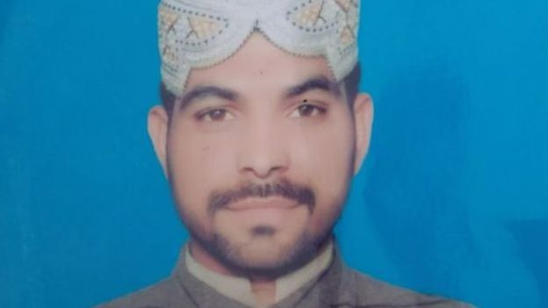Image copyrightPOLICE HANDOUTImage captionImran Ali, 24, was convicted for several rapes and murde
However Mr Ansari, who said that Zainab would have been seven years and two months old if she was alive, expressed regret that authorities did not televise the hanging.
Mr Ansari's earlier appeal for Ali to face a public hanging was dismissed by the Lahore High court.

#JusticeforZainab
Zainab disappeared on 4 January and her body was found five days later in a rubbish dump.Police said there had been several similar child murders in the past two years in Kasur but her killing proved to be a tipping point.It triggered widespread outrage, including protests complaining of police incompetence. Two people were killed in clashes.Zainab's family said the police did not take action during the five days from when she was reported missing until her body was found. Relatives, not police, recovered CCTV footage of her last movements.The footage, which showed a girl being led away by a man, was circulated widely on social media. The hashtag #JusticeForZainab later went viral, with many Pakistanis calling for action.On 23 January, 24-year-old Imran Ali was arrested through a DNA match. He was sentenced to death in February for Zainab's rape and murder.His appeals against the verdict failed and earlier this month President Arif Alvi rejected a plea for clemency.

9 Ukhano hIT BY MEETO

Famous Pakistani youtuber ‘Ukhano’ denies all harassment allegations but Pakistanis are not buying it!
As the YouTube community in Pakistan is growing really fast, various alleged issues are also coming into notice. There’s no doubt that Pakistan has some extremely talented minds who have made a worthy name in a short span of time. Creating amazing content and attracting a large audience isn’t everyone’s cup of tea but several creative individuals made it happen with their consistent nature.
Notably, among famous names from Pakistan’s YouTube community, one is currently stuck in harassment allegations. YouTuber Umar Khan who goes by the name ‘Ukhano’ on social platforms, is facing severe harassment accusations. This has made his followers sure disappointed. The issue got controversial after a girl shared the screenshot of her conversation with the YouTuber on Twitter. Consequently, the matter just got bigger.Everyone was busy cursing Ukhano because of the viral conversation screenshots on social media. Many took the matter sensibly as there was no statement released by the YouTuber himself on the matter. Finally yesterday, Ukhano posted a video on his official Instagram providing his part of the story regarding the allegations.Apparently, things revealed that there were other girls who had the same issue with Ukhano.
According to this girl here’s the screenshot of the Snapchat conversation which happened between her and Ukhano!

In brief, after these conversations were shared online, some other girls also shared their conversation screenshots with the girl and this is really disappointing! Screenshot of an Instagram conversation happened between some girl and the YouTuber!

Irfan Junejo Speaks Up Against Ukhano
Last we heard, Mooroo had tweeted in favor of Ukhano and the harassment controversy taking social media by storm. Now, an equally popular (if not more) vlogger and social media influencer, Irfan Junejo has taken to Twitter to reveal his stance on the matter.
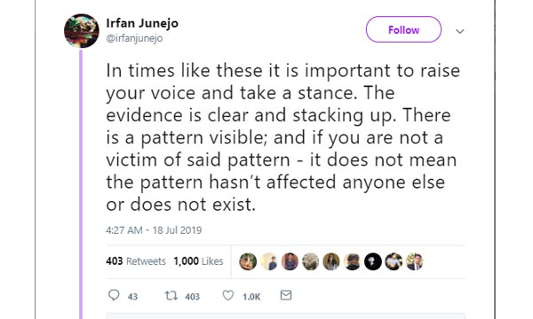
Moreover, he stands in solidarity with the victims and has shown trust in them and the problems they have faced because of the youtuber.

10 Choate Rosemary Hall's Handling Of Sexual Misconduct At The School
Choate Rosemary Hall, an elite Connecticut boarding school, came under fire for hushing up sexual abuse that occurred at the school. Choate had handled instances of adult sexual misconduct internally rather than report them to the Connecticut Department of Children and Families. In 2016, The Boston Globe published an investigation about sexual abuse New England schools and this April, Choates’s report to its board of trustees documented an investigation (started following the Globe story) that found decades of sexual abuse. In response, the chair of the board and the school’s headmaster sent a letter of apology to the community.
It’s clear that the school handled the allegations improperly, but it was right to apologize now that the truth had been uncovered. In a crisis, taking responsibility is one of the most important things you can do. The public deserves an apology and will perceive the brand, organization, or in this case, the school, as indifferent to the situation if an apology isn’t made.
11 Fox News' Firing Of Bill O'Reilly
In late April, Fox News fired host Bill O'Reilly. Fox’s firing of O’Reilly was bold: He had the network's highest-rated program. In early April, The New York Times reported that O’Reilly had sexually harassed a number of female guests and employees of the show and that five women had been paid a total of $13 million in settlements for it. In the wake of the recent, similar Roger Ailes scandal and more than 50 advertisers dropping from O’Reilly’s show following the allegations, it was clear that Fox needed to make the move quickly to avoid further tarnishing its reputation and to protect itself moving forward.
There are valuable lessons to be learned from these PR crises. A key takeaway for brands is that it’s necessary to apologize immediately after an offensive mistake has been made, especially in the current age of social media, when minor missteps are amplified into major crises within a matter of minutes. Refusing to acknowledge a mistake or apologize will create additional negative attention, and the longer you wait, the worse it will be. The general public will be using social media to voice their expectations of what you should do while they anticipate your response. In a crisis, consumers deserve an apology, and they expect it to be immediate, sincere and devoid of corporate jargon.
Ronn TorossianRonn Torossian is founder and CEO of 5WPR. Under his leadership, 5WPR has grown into one of the 15 top independent PR firms in the nation.

